Digital Weighing Machine

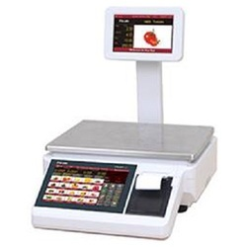

High Level Requirements:

* Accuracy: A weighing machine should be highly accurate.
* Display: The weight should be visible on the LCD.
* Battery powered: The machine should run on battery power supply.
* Calibration: Each item placed on the machine should be calibrated in terms of mass and weight.

Low Level Requirements:

* LCD: To display the weight.
* Keyboard: To enter the units.
* Load Cell Sensor:The weigh-scale uses a resistive bridge type load-cell pressure sensor.
* LED: It should blink when a weight is placed.
* Portability: Should be of a size that can be carried easily.

Block diagram and design:

